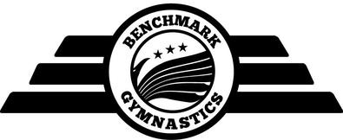

Sydenham Class Dates 2017/2018 (Mondays)

For the 2017/2018 academic year Sydenham General Gymnastics Classes will be on the following dates except where noted in red.

September 2017 |  | March 2018
4th September 2017  11th September 2017  18th September 2017  25th September 2017 |  | 5th March 2018  12th March 2018  19th March 2018  26th March 2018
October 2017 |  | April 2018
2nd October 2017  9th October 2017  16th October 2017  23rd October 2017 (Half Term - No Classes)  30th October 2017 |  | 2nd April 2018 (Easter Monday - No Classes)  9th April 2018 (Easter Break - No Classes)  16th April 2018  23rd April 2018  30th April 2018
November 2017 |  | May 2018
6th November 2017  13th November 2017  20th November 2017  27th November 2017 |  | 7th May 2018 (Bank Holiday - No Classes)  14th May 2018  21st May 2018  28th May 2018 (Half Term - No Classes)
December 2017 |  | June 2018
4th December 2017  11th December 2017  18th December 2017  25th December 2017 (Christmas Break - No Classes) |  | 4th June 2018  11th June 2018  18th June 2018  25th June 2018
January 2018 |  | July 2018
1st January 2018 (Christmas Break - No Classes)  8th January 2018  15th January 2018  22nd January 2018  29th January 2018 |  | 2nd July 2018  9th July 2018  16th July 2018  23rd July 2018 (Summer Break - No Classes)  30th July 2018 (Summer Break - No Classes)
February 2018 |  | August 2018
5th February 2018  12th February 2018 (Half Term - No Classes)  19th February 2018  26th February 2018 |  | No classes

Re-enrolment for 2018/2019 Classes
Monday 2nd July 2018 - Monday 9th July 2018
(All dates subject to change)

